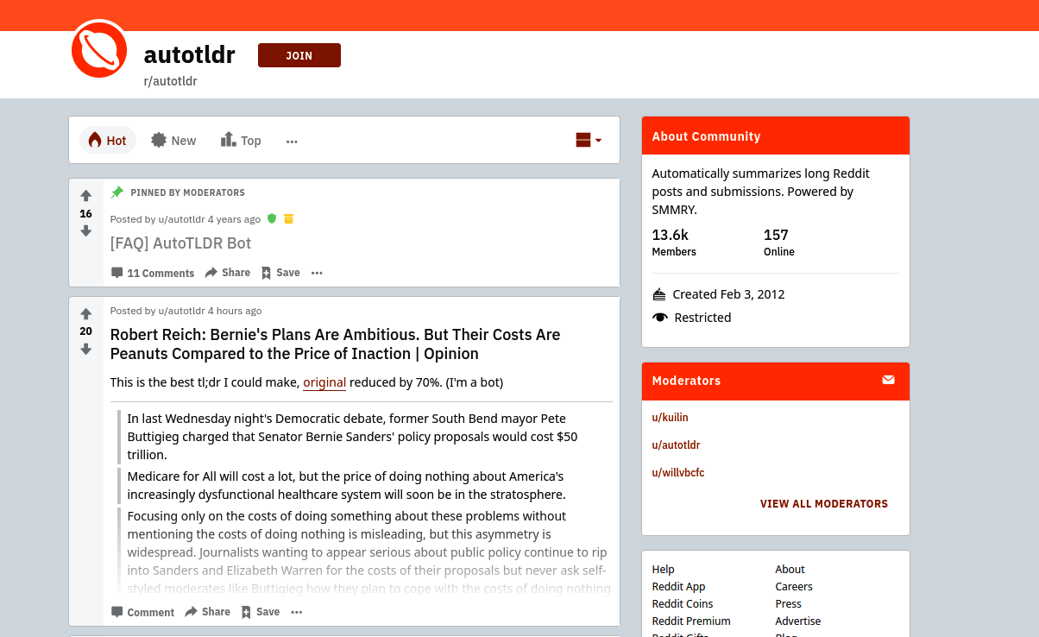

e.g - real-world product is the autotldr bot on Reddit

Text summarization refers to the task of creating a summary of a longer piece of text. The goal of this task is to create a coherent summary that captures the key ideas in the text. It’s useful to do a quick read of large documents, store only **relevant information**, and facilitate **better retrieval of information**

*Extractive versus abstractive summarization*

Extractive summarization refers to selecting important sentences from a piece of text and showing them together as a summary. Abstractive summarization refers to the task of generating an abstract of the text; i.e., instead of picking sentences from within the text, a new summary is generated.

*Query-focused versus query-independent summarization*

Query-focused summarization refers to creating the summary of the text depending on the user query, whereas query-independent summarization creates a general summary.

*Single-document versus multi-document summarization*

As the names indicate, single-document summarization is the task of creating a summary from a single document, whereas multi-document summarization creates a summary from a collection of documents.

Sumy [[26](https://learning.oreilly.com/library/view/practical-natural-language/9781492054047/ch07.html#idm44947050862696)] is a Python library that contains implementations of several popular query-independent, extractive summarization algorithms.